

BUG MANAGEMENT PROCESS

TEMPLATE

**Version 1.0**

**Qui Ngo**

**Revision History**

|  |  |  |  |
| --- | --- | --- | --- |
| **Version** | **Date** | **Author** | **Content** |
| 1.0 | 16/05/2017 | Qui Ngo | Release Bug Management Process Version 1.0 |

Table of Contents

**List of Figure** 3

**1. Introduction** 3

**1.1. Purpose** 3

**2. Bug Management** 3

**2.1. Process** 3

**2.2. Process Description** 4

**2.3. Role & Responsibilities** 6

**3.Configuration in project** 6

**3.1 Priority** 6

**3.2 Tracker** 6

**3.3 Status** 6

**4. Document deliverables** 7

**List of Table**

TABLE 1. BUG DESCRIPTION 7

TABLE 2. ROLE AND RESPONSIBILITY 7

TABLE 3. PRIORITY 7

TABLE 4. TRACKER 7

TABLE 5. STATUS 8

TABLE 6. DOCUMENT DELIVERABLES 8

**List of Figure**

FIGURE 1 . BUG PROCESS 5

# **1. Introduction**

## **1.1. Purpose**

This document describes how to use tool for managing bugs and changes in ECB Project.

# **2. Bug Management**

## **2.1. Process**

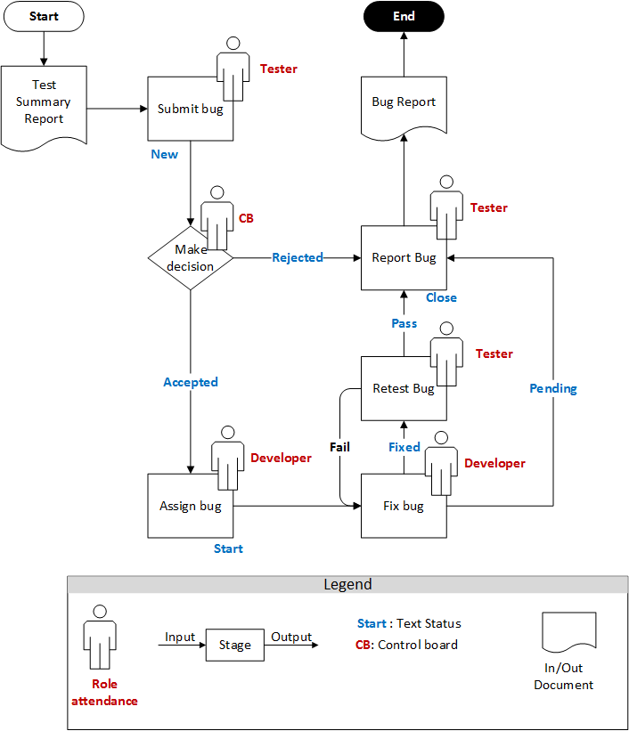

FIGURE 1 . BUG PROCESS

## **2.2. Process Description**

|  |  |  |  |  |
| --- | --- | --- | --- | --- |
| Stage | Description | Input | Output | Role |
| Submit bug | When bug is found, tester will add new bug in project include information: Tracker, Subject, Description, Status, Priority, Assignee, Start date, Due Date with status is “New”. | Test Summary Report |  | Tester |
| Make decision | Change Board identify bugs from list bug report be submit, will be 2 case:   * Accepted * Rejected |  |  | CB |
| Assign bug | Change board will assign member that responsibility to fix this bug. With this case, bug is in status “Start”. |  |  | Developer |
| Fix bug | Developer will fix the bug that assigned and inform to Leader implement to change the status to in progress. We have 2 cases:   * If developer fixed the assigned bug, developer will report tester to retest and status “Fixed”. * If over deadline time that not fixed the bug or bug related to the following functions, developer will report to tester to resolve “Pending. |  |  | Developer |
| Retest bug | * Tester will retest the bug that was fixed completely. If the fixed bug is enough conditions for passing, change status for bug with status “Pass”. * In the opposite case test case fail, tester will assigned to developer again or additional human resource to fix this bug again |  |  | Tester |
| Report bug | After complete fix of the bug Tester will document the bug with name “Bug Report” |  | Bug Report |  |

TABLE 1. BUG DESCRIPTION

## **2.3. Role & Responsibilities**

|  |  |  |
| --- | --- | --- |
| No. | Roles | Responsibility |
| 1 | Test leader | Control test team, bug management and assign task |
| 2 | Tester | Run test case, test document and report |
| 3 | Control board | Include: Project Manager, Configuration Manager, Leader phase. they are roles identify and make decision bug |
| 4 | Developer | Fix bug and report |

TABLE 2. ROLE AND RESPONSIBILITY

# **3.Configuration in project**

## **3.1 Priority**

|  |  |
| --- | --- |
| No. | Priority |
| 1 | Low |
| 2 | Medium |
| 3 | High |
| 4 | Urgent |
| 5 | Immediate |

TABLE 3. PRIORITY

## **3.2 Tracker**

|  |  |  |
| --- | --- | --- |
| No. | Type | Description |
| 1 | Bug | Defect of software |
| 2 | Feature | Set of functions |
| 3 | Support | Issue about support. |
| 4 | Enhancement | A Upgrade |
| 5 | Change | Request for change |
| 6 | Document | Issue about document. |

TABLE 4. TRACKER

## **3.3 Status**

|  |  |
| --- | --- |
| Status | Description |
| New | Create new has not been reviewed previous |
| In Progress | Duration process. |
| Close | Indicates that the issue is considered as closed |
| Reject | Decline to fix bug |
| Resolved | Require to fix bug again |
| Start | Start handling issue |
| Pending | Over deadline time that not fixed the bug or bug related to the following functions |

TABLE 5. STATUS

# **4. Document deliverables**

|  |  |
| --- | --- |
| No. | Description |
| 1 | Triplex_ BugReport |

TABLE 6. DOCUMENT DELIVERABLES